27th September 2018

Dear Parent/Carer

We have launched a new method of parental communication with school. The communication channel is in the form of an app for your smart phone which will enable you to have instant access to some information regarding your son/daughter and also about our school.

The app once downloaded on to your phone will give you current information regarding attendance, punctuality, letters, exam timetables, reports and other documents.

You will need to download the app from either the app store or play store on your smartphones.

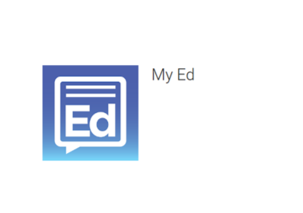

The phone number must be the same as the one in our school records. Your son/daughter cannot download and register the app on their own phones.

If there are any difficulties with downloading or logging on to the app then please contact us via a note in son/daughter’s home learning diary.

Yours sincerely



Mrs D Kullar

Assistant Headteacher