

6th Form News April 2018

It has been a busy start to the summer term for the 6t form. Students have returned from the Easter break with an even greater sense of focus and determination to succeed in the summer exams. Mr Fenlon gave some excellent revision advice in assembly

[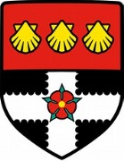](https://www.bing.com/images/search?q=reading+university+logo&FORM=IARRTH&ufn=University+Of+Reading&stid=594e7957-ec64-b20e-5cb4-b6e3518c71c8&cbn=EntityAnswer&cbi=0&FORM=IARRTH)Year 12 students who have won places on the **Reading University Scholars programme** attended a third day of lectures and workshop with a focus on developing revisions skills and note taking. They are now looking forward to the next stage of the programme- a three day residential.

Our scholars are: Art - Lady and Imaan; Biology – Afreen, Megha and Fadumo; Chemistry- Nithursha and Shahzadi; Mathematics- Monisha, Mathumitha, Abbishna and Ellaha; English- Hemayal, Shreya, Azim and Tahreem

Meanwhile our Year 12 physicists enjoyed a visit to Royal Holloway University where they participated in a Particle Physics Master Class

Lovely to see that our Year 12 students have started to work with students in Dormers Wells Junior School supporting them in their reading.

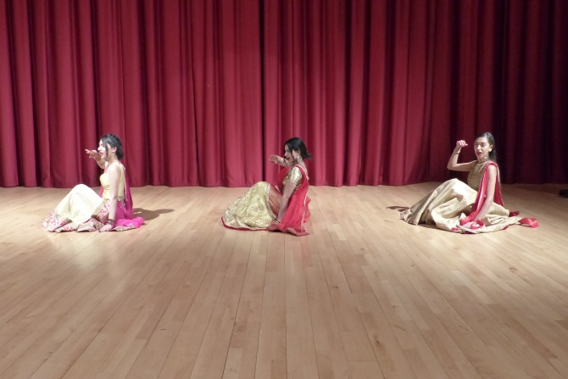

The 6th form made a wonderful contribution to **International Evening** on Thursday 20th April.

Their production and performance skills ensured an unforgettable evening for everyone

[](https://www.bing.com/images/search?view=detailV2&ccid=pffZqo1j&id=BF3EB02EE3C5EB260FD81467DBF51FE8FEE1B84C&thid=OIP.pffZqo1jLVBgX_3_ov1_6wHaE2&mediaurl=http://1.bp.blogspot.com/-4C5ggs_eQ3o/UXRIlGtkK2I/AAAAAAAAAMk/vznxlmu6PlQ/s1600/prom_0018.jpg&exph=590&expw=900&q=prom&simid=608032114251206139&selectedIndex=1)

The 6th Form Prop will take place in July at Horizons Banqueting in Hounslow

Deposits have been taken and full payment can be made through Squid



Year 13 Leavers’ hoodies can be ordered through Squid. Please get your orders in as soon as possible (bursary can be used for payment).

6th Form Opportunities

cid:image002.png@01D228B4.54FF2F80Applications fora September-December 2018 work experience placement for students opened this week and will close at midnight on Wednesday 25th April 2018. All placements on this nationally accredited programme are for 5 days –- over 25 departments offer work experience placements. If their application is successful, students will be invited to an interview day during May half term, as part of our ongoing employability strategy to support young people develop work readiness skills. On this interview day, they can then declare which weeks they are available to do their placement. Some of the opportunities for work experience include ; Business and head office; Customer Services and front line operations ; Engineering and operations. Please note that students can only apply for one placement.  For more information or to apply for a placement, please visit our website: [https://jobs.ba.com/jobs/studentsgraduates/workexperience**/**](https://jobs.ba.com/jobs/studentsgraduates/workexperience/)

***For more information, please look on our work experience careers website:*** <https://jobs.ba.com/jobs/studentsgraduates/workexperience/>

**[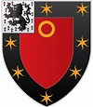](https://www.bing.com/images/search?q=st+johns+college+oxford+logo&id=64D8AF13F803BAB30F193189741ECD80C145DEB6&FORM=IARRTH)**On Saturday 16 June 2018, St John’s College will be holding a study day for high achieving Year 12 students who are considering studying English Language and/or Literature at university. Study days are designed to give students a taste of what it’s like to live and study as an undergraduate at St John’s College and the University of Oxford. Participants will enjoy academic taster sessions, spend time with current undergraduate students and eat in the College dining hall. Further details about how to apply can be found here: <https://www.sjc.ox.ac.uk/study/working-schools/study-days/> . Deadline for applications: Wednesday 23 May 2018

[](https://www.bing.com/images/search?view=detailV2&ccid=fgZ/k2LK&id=11DEF864D179E65F89A018CB5CECB27BA9DC4DDE&thid=OIP.fgZ_k2LKX_EeZVrwfB08iAHaIh&mediaurl=http://bloximages.chicago2.vip.townnews.com/dailysentinel.com/content/tncms/assets/v3/editorial/5/bf/5bf3c61c-4ad8-11e5-b3f0-13eb087adb59/55dbdf5959551.image.jpg&exph=460&expw=400&q=shout+out&simid=608019602979556108&selectedIndex=7)

Year 13 presented their projects (EPQ) on Tuesday 17th April. Judges are very impressed by the quality and delivery of the students. Presenting was:

AHUJA Tanmeet - Sleep’s impact on forming mental disorders

ALKESH Aayush – Time-travel

AHMED Shahir – Could the Ironman Exoskeleton exist?

VAGHJIANI Rianna – causes of the financial crisis in 2008

CARTER Chloe - Education system fit for purpose?

GROVER Parmeat – Living on Mars

DEOL Gurpreet – Getting to the stars

ADAM  Zumaya – Antibiotic resistance

ADAM  Zundus - Genetic engineering, CRISPR and the ethics associated.

SIAM Manpreet – Ancient Egyptian Culture compared to western culture today

KANENDRAN Krishnika - Sri Lankan civil war

6th formers who helped stage a stunning International Evening

Production team: Krusha Gohel 12BG- Piano; Elfleda Akoto 12WN; Ruth Ndagire 12HB; Adnan Shinwari 12OL- Host (plus1); Josef Al Shemary 12GU; Nii-Ayi Aryee 12 MR; Harshwarya Kaur 12MR; Anika Sharma 12PT; Aayush Alkesh 13OL; Azim Malik 12PT and Adil Shafi 12BG.

Performers: Shreya Markendey 12MR- - Dance; Saphalata Oli 12WR- Dance; Simranjit Talwar 12BG- Dance; Kenza Chaib 12MR- Poem (Arabic) & dance; Manvir Kalsi 13PT, Leo Jefimovs and Arvinder Singh 13RO- Dance

Year 12 students supporting DWJS students with their reading:

Imaan Yazdan SRO

Rahila Puthanpeediyakkal SPT

Gaganpreet Kaur SPT

Monisha Elangeswaren SWR

Abbusha Savalingam SRO

Aayza Sheikh SMR

Mathumitha Jeevahan SWR

Isha Kaur SOL

Tharaniya Panchalingham SBG

Anika Sharma SPT

And finally…

Lady Ashong who has got to the next stage of the Fulbright American Universities Scholarship programme and will be spending a week of her summer holidays in America visiting Ivy League universities.